Functional & Performance Testing Template
Model Performance Test
Date | 28 September 26
Team ID | 6ab221d587602313e82c60c9
Project Name | Project - Import Data using Transform Maps (Spreadsheet)
Maximum Marks

Test Scenarios & Results
Test Case ID | Scenario (What to test) | Test Steps (How to test) | Expected Result | Actual Result | Pass/Fail
FT-01 | Spreadsheet File Validation (e.g., .xlsx / .csv, column headers) | Upload a valid file and an invalid file using System Import Sets > Load Data | Valid file loads into the staging table; invalid file shows an error
FT-02 | Field Mapping Validation (e.g., name, email, department) | Open the Transform Map, map source fields to target fields and run the transform | Values are stored in the correct target table fields
FT-03 | Data Transformation (e.g., employee records) | Click Transform on the import set and open the target table | Records are created correctly based on the mapping
FT-04 | Coalesce / Duplicate Check | Import the same rows again with a coalesce field (e.g., Email) set | Existing records are updated, no duplicates created
PT-01 | Import Time Test | Note the start and end time of the transform in Transform History | Should complete within acceptable time (e.g., under 1 minute)
PT-02 | Bulk Data Load Test (e.g., 500+ rows) | Upload a spreadsheet with a large number of rows and run the transform | Should load smoothly without errors or slowing down
PT-03 | Multiple File Upload Test (e.g., 2-3 spreadsheets) | Upload and transform multiple spreadsheets one after another | Should work smoothly without crashing

Test Evidence – Screenshots
FT-01 – Spreadsheet File Validation
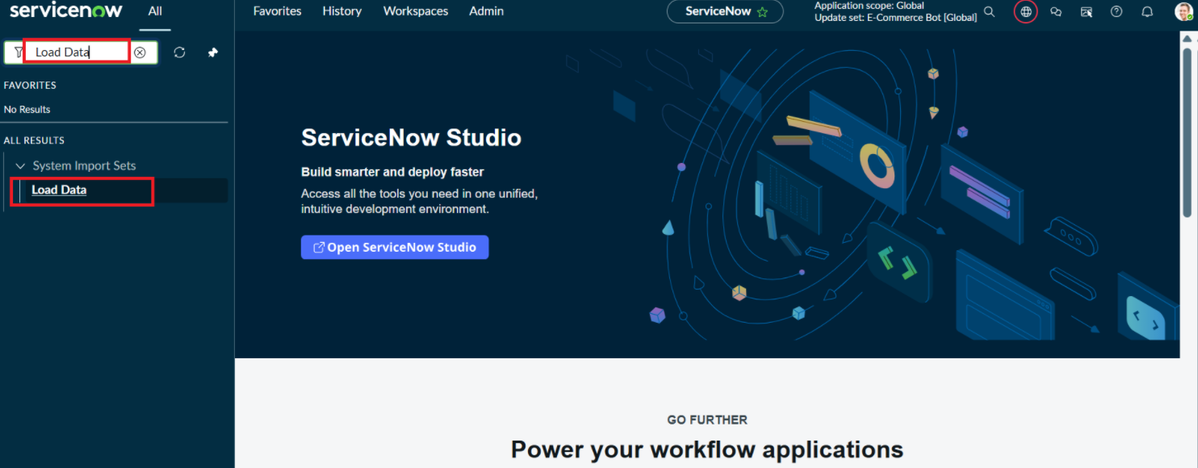
Application Navigator → System Import Sets → Load Data
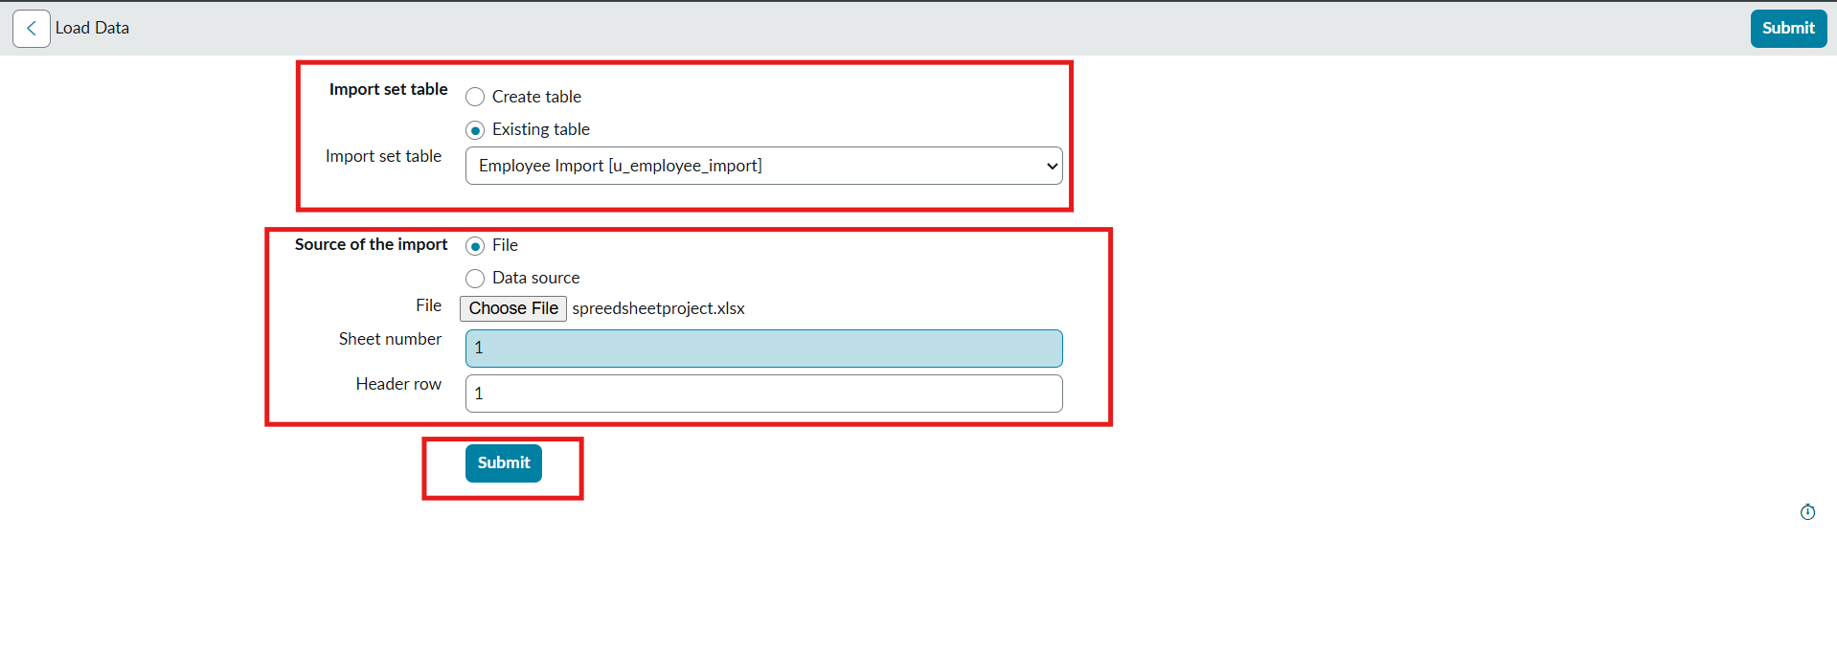
Load Data form: existing table Employee Import, file spreadsheetproject.xlsx, sheet 1, header row 1

Valid file loaded into staging table: State Complete – Processed 4, errors 0
Note: invalid-file (negative) test screenshot is not available in the project document.
FT-02 – Field Mapping Validation
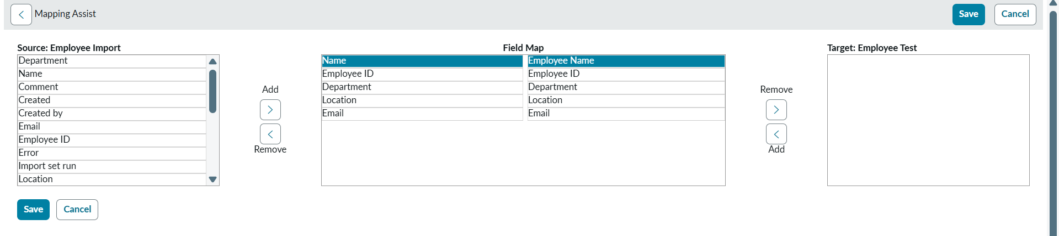
Mapping Assist: source fields mapped to target fields

Field Maps: u_name, u_employee_id, u_department, u_location, u_email mapped to Employee Test fields
FT-03 – Data Transformation

Transform completed: State Complete, Completion code Success

Records created in the Employee Test target table
FT-04 – Coalesce / Duplicate Check

Coalesce set to true on Employee ID field map

Transform History: Total 4, Inserts 2, Updates 2 (no duplicates)
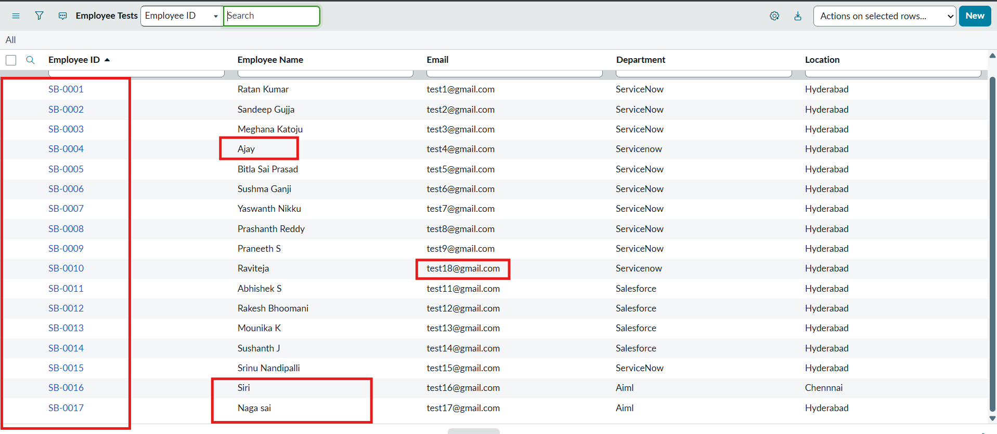
Employee Test table: existing rows updated, new rows inserted

Same sheet re-imported: Inserts 0, Updates 0, Ignored 4
PT-01 – Import Time Test
Transform History – Run time: 1 Second
Transform History – Run time: 0 Seconds
PT-02 – Bulk Data Load Test (500+ rows)
No matching screenshot in the project document (only 4–17 rows were loaded). A 500+ row test still needs to be run and captured.
PT-03 – Multiple File Upload Test
First upload transformed (ISET0010003) – Complete, no errors
Second upload transformed (ISET0010004) – Complete, no errors
Note: the second upload reused the same spreadsheet, not a different file.

